EXPERIMENT - 4
4. Implement histogram equalization on the given image and compare it with
the original image using Open CV.
Aim
To implement Histogram Equalization on a given image and compare the equalized image with
the original image using OpenCV.
Procedure
1. Import the OpenCV library.
2. Read the input image using cv2.imread().
3. Convert the image to grayscale.
4. Apply histogram equalization using cv2.equalizeHist().
5. Display the original grayscale image and the histogram-equalized image.
6. Display the histograms of both images for comparison.
7. Wait for a key press and close all windows.
Program
import cv2
import matplotlib.pyplot as plt
image = cv2.imread("image.jpg")
if image is None:
print("Image not found!")
else:
gray = cv2.cvtColor(image, cv2.COLOR_BGR2GRAY)
equalized = cv2.equalizeHist(gray)
cv2.imshow("Grayscale Image", gray)
cv2.imshow("Histogram Equalized Image", equalized)
plt.figure(figsize=(10, 4))
plt.subplot(1, 2, 1)
plt.hist(gray.ravel(), 256, [0, 256])
plt.title("Original Histogram")
plt.xlabel("Pixel Intensity")
plt.ylabel("Frequency")
plt.subplot(1, 2, 2)
plt.hist(equalized.ravel(), 256, [0, 256])
plt.title("Equalized Histogram")
plt.xlabel("Pixel Intensity")
plt.ylabel("Frequency")
plt.tight_layout()
plt.show()
cv2.waitKey(0)
cv2.destroyAllWindows()
Sample Input
Image.jpg
Sample Output
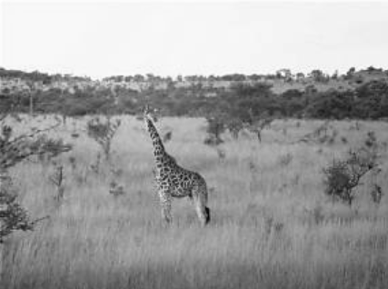
Sample Output
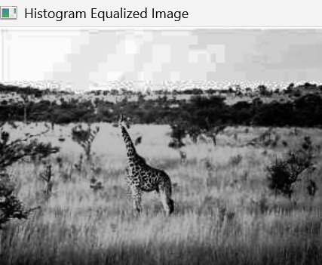
Result
Thus, histogram equalization was successfully implemented using OpenCV, and the original
image was compared with the histogram-equalized image.

